W-11

**YEAR 12 PHYSICS**

**ASS. 2 - CIRCULAR MOTION, GRAVITATION**

**NAME: TOTAL: **

**DUE DATE:**

1. Mount Everest is 8.85 km high. The acceleration due to gravity on the top of Mount Everest is:

A. About the same as at sea level.

B. About 10% less than at sea level.

C. Much less than at sea level. Answer (1)

Explain how you arrived at your answer.

(2)

2. A 1.25 tonne car is driven on two bridges at a speed of 72.0 kmh-1. Bridge A is straight and level.

Bridge B is part of a circular curve with a radius of 80.0 m (see diagrams below). For each bridge,

find the vertical force exerted by the bridge due to the weight of the car.

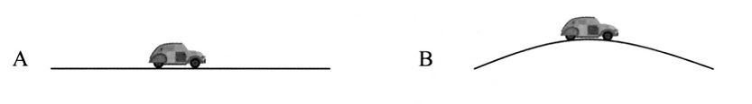

(4)

3. A satellite is in a low Earth orbit, 7.90 x 102 km above the surface.

(a) Calculate the satellite's orbital speed.

(3)

(b) Hence, calculate the period of its orbit.

(2)

4. The diagram below shows a toy car doing a 'loop the loop'. The car just remains in contact with the

track at the top of the circle. The loop has a radius of 0.400 m. If the car starts from rest at point A,

what is the height of A above the ground? You should ignore any effects due to friction.

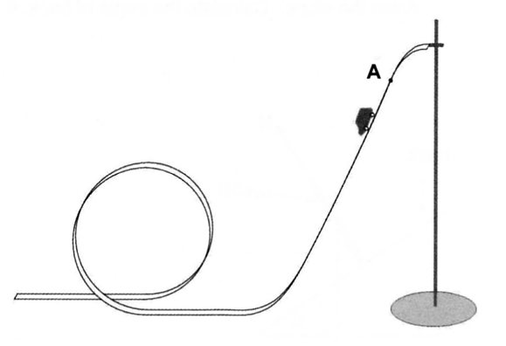

(5)

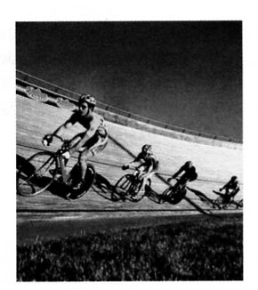5. A velodrome is an oval-shaped cycle track, parts of which are steeply banked.

The riders in the picture are travelling at 15.5 ms-1, the radius of curvature of

the banked track is 35.0 m and there is no tendency for the bikes to slide up or

down the slope.

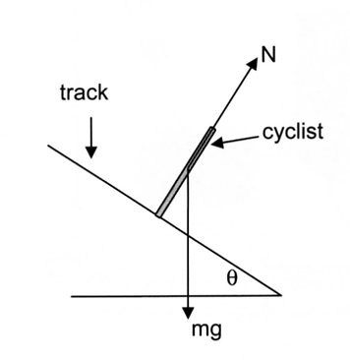

(a) Derive an equation to show the relationship between the speed of the riders and the angle of the

banking.

(3)

(b) Calculate the angle of the bank, .

(2)

6. The planet Jupiter orbits the Sun with a period of 4333 days. It has a mass 318 times larger than the

mass of the Earth and a diameter 11.2 times larger than the diameter of the Earth.

(a) Calculate the period of Jupiter's orbit in seconds.

(2)

(b) Assuming that Jupiter has a circular orbit with a radius of 5.20 AU (astronomical unit), where

1.00 AU is the distance from the Earth to the Sun, calculate the speed of Jupiter in orbit around

the Sun.

(3)

The orbit of Jupiter is known to be elliptical rather than circular. At Jupiter's closest point, it is

4.95 AU from the Sun and at its most distant point it is 5.46 AU from the Sun.

(c) Calculate the force of gravitational attraction between Jupiter and the Sun when Jupiter is most

distant from the Sun.

(3)

(d) Calculate the speed of Jupiter in its orbit when it is most distant from the Sun.

(3)

When it is closest to the Sun, the force of attraction between Jupiter and the Sun is 4.60 x 1023 N and

its orbital speed is 1.25 x 104 ms-1.

(e) Which one of the following statements best describes the motion and energy of Jupiter as it

orbits the Sun?

A. The kinetic energy of Jupiter does not change as it orbits the Sun.

B. The kinetic energy of Jupiter keeps increasing as it orbits the Sun.

C. The total energy of Jupiter stays the same as it orbits the Sun; the kinetic energy

increases as the gravitational potential energy decreases.

D. At its nearest point to the Sun, Jupiter has the most energy; its kinetic energy is

very big and it also has a large gravitational potential energy.

E. Gravitational potential and kinetic energy change depending on where Jupiter is in

its orbit; its potential and kinetic energy both increase as Jupiter gets closer to the

Sun.

Answer

(1)

8. A student ties a string to a rubber ball and then whirls it so that it moves in a horizontal circle at

constant speed. You should assume that air resistance is negligible.

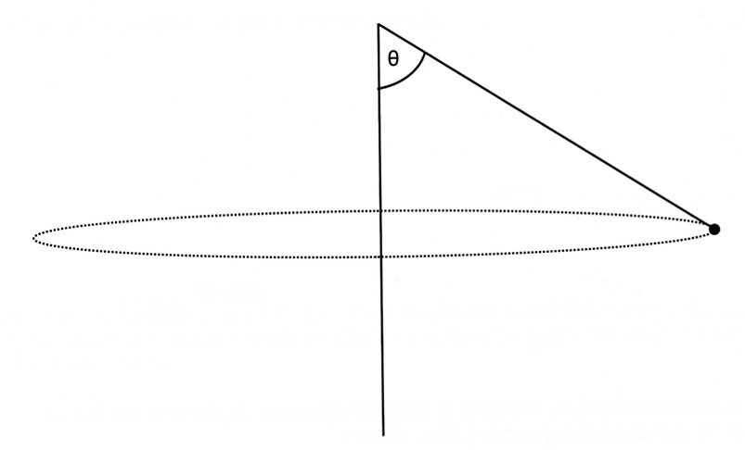

(a) On the diagram, draw and label arrows representing the forces acting on the ball.

Explain why the string is not horizontal (in other words why  is not 90.0°).

(3)

(b) On the diagram, draw and label an arrow representing the direction of the acceleration of the

ball. (1)

The mass of the ball is 0.0500 kg, the length of the string from the student's hand to the ball is 0.500 m

and  = 75.0°.

(c) Calculate the tension in the string.

(3)

(d) Calculate the orbital speed of the ball.

(4)

9. The dwarf planets Pluto and Charon form part of the Kuiper belt that orbits the Sun. The centres of

Pluto and Charon are ***always*** 19 570 km apart. In addition to orbiting the Sun, Pluto and Charon orbit

a point between them called the barycentre. The barycentre ***always*** lies on a straight line between

Pluto and Charon. This is illustrated in the diagram below. The diagram is not drawn to scale.

Pluto has a mass of 1.30 x 1022 kg; Charon has a mass of 1.52 x 1021 kg.

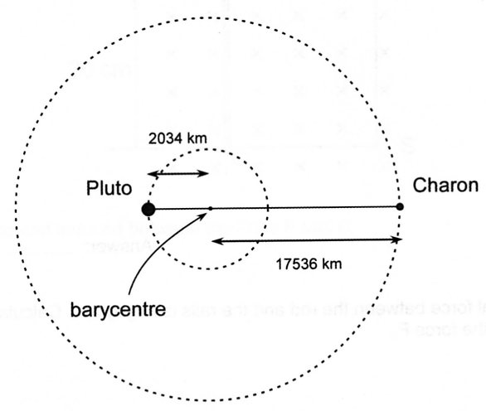

(a) Calculate the magnitude of the gravitational force of attraction between Pluto and Charon.

(3)

(b) Calculate the speed of Pluto around the barycentre.

(3)

(c) (i) How long, in Earth days, does it take Pluto to orbit the barycentre? If you were unable to

determine a speed in part (b), use 24.0 ms-1.

(3)

(ii) Mark on the diagram the position of both Pluto and Charon 1.60 Earth days after

their initial position on the diagram. Assume Pluto orbits in a clockwise direction.

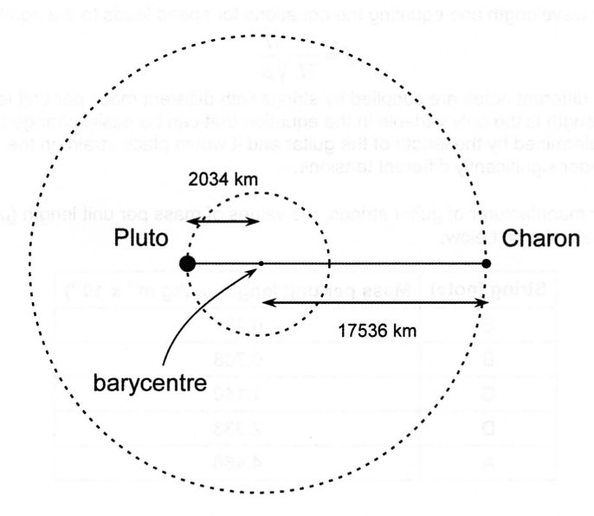

(2)

10. This question is about the gravitational field around an asteroid. The asteroid is spherical and of

uniform density. The diagram below shows lines of equal gravitational field strength as dashed lines.

There is a constant ratio in the value of the field strength between each line.

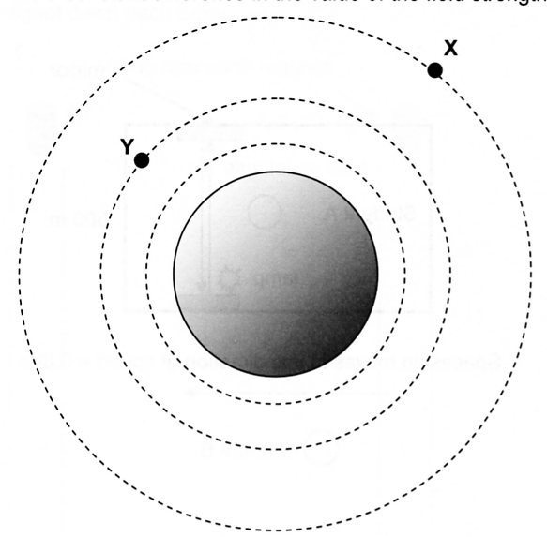

(a) Describe what the diagram shows about the gravitational field strength as the distance from the

asteroid increases.

(1)

(b) Draw vectors to represent the gravitational field at points X and Y. (2)

(c) The asteroid has a radius of 1.25 x 105 m. If the gravitational field strength on its surface is

0.194 Nkg-1, calculate the mass of the asteroid.

(3)